Example Title

Example Subtitle (optional)
John Doe* (Department of Example, Example University, Germany; j.doe@example.edu)
Sarah Sample (Independent Researcher, USA; sarahsample@example.com)
Peter Pattern (Department of Example, Other University, Finland; pattern@example.edu)
Please note: Should you choose to submit this manuscript as your initial contribution to Urban Eidos, it is important that you exclude any identifying information pertaining to the authors to adhere to the journal’s double-blind review process.
After the acceptance of your manuscript for publication, you will be requested to furnish comprehensive details of each contributor. In cases where the manuscript is co-authored, kindly mark the corresponding author with an asterisk. Additionally, you are welcome to annotate the author information with footnotes for further clarification, such as instances where multiple individuals have made equivalent contributions to the work submitted.
Abstract
Please provide an abstract that is no longer than 1.500 characters including blanks and punctuation. Do not include any footnotes or references in this section.
Keywords
Please provide between 4–6 concise keywords that define the content of your contribution (e.g. Architecture; Philosophy; Urban Planning; Aesthetics). Separate each keyword with a semicolon.
Headline H1 (style: UE H1)
Start with your main text here. If you need to emphasize certain expressions, we encourage you to use italics. Please refrain from using bold or underline as typographical emphasis if possible. Please refrain from using either manual or automatic hyphenation.
Use quotation marks for “direct quotes”. After a “direct quote” a reference is needed. References are always given in footnotes. You may also include textual comments in your footnotes but please use this option sparingly. In general: Always make sure to cite your sources. Use ‘single quotation marks’ to signify expressions that should not be interpreted literally, but rather read with irony or detachment. Additionally, single quotation marks may be utilized for quotations within a direct quote, which is encased in double quotation marks. For instance: “when Shakespeare writes: ‘Hold, please!’, this constitutes a […] reference to an external context”. In direct quotations, any omissions made should be indicated using ellipses enclosed in square brackets [...]. If a direct quote is longer than 250 characters (incl. blanks and punctuation) please use the dedicated style template ‘UE long quote’ to indent this paragraph.
“This serves as an illustration of a lengthy quotation exceeding 250 characters. To achieve the requisite indentation and reduced font size, a stylistic template has been included in this template to guarantee the appropriate typographical configurations on your behalf. This template is accessible within the ‘Styles and Formatting’ section of the menu (UE long quote). Do not forget to include a footnote after your long quote to cite its origin.”
References may also be indirectly acknowledged by appending a footnote subsequent to the segment necessitating citation. If possible avoid two consecutive footnote references with no body text in between, such as this bad example. If you need to cite two or more sources you can do this in one combined footnote.
Headline H2 (optional) (style: UE H2)
Lorem ipsum dolor sit amet, consectetur adipiscing elit, sed do eiusmod tempor incididunt ut labore et dolore magna aliqua. Ut enim ad minim veniam, quis nostrud exercitation ullamco laboris nisi ut aliquip ex ea commodo consequat. Duis aute irure dolor in reprehenderit in voluptate velit esse cillum dolore eu fugiat nulla pariatur. Excepteur sint occaecat cupidatat non proident, sunt in culpa qui officia deserunt mollit anim id est laborum.
Headline H3 (optional) (style UE H3)
Lorem ipsum dolor sit amet, consectetur adipiscing elit, sed do eiusmod tempor incididunt ut labore et dolore magna aliqua. Ut enim ad minim veniam, quis nostrud exercitation ullamco laboris nisi ut aliquip ex ea commodo consequat. Duis aute irure dolor in reprehenderit in voluptate velit esse cillum dolore eu fugiat nulla pariatur. Excepteur sint occaecat cupidatat non proident, sunt in culpa qui officia deserunt mollit anim id est laborum.
Unnumbered List
- Lorem ipsum dolor sit amet, consectetur adipiscing elit, sed do eiusmod tempor incididunt ut labore et dolore magna aliqua.
- Ut enim ad minim veniam, quis nostrud exercitation ullamco laboris nisi ut aliquip ex ea commodo consequat. Duis aute irure dolor in reprehenderit in voluptate velit esse cillum dolore eu fugiat nulla pariatur.
- Excepteur sint occaecat cupidatat non proident, sunt in culpa qui officia deserunt mollit anim id est laborum.
Numbered List
- Lorem ipsum dolor sit amet, consectetur adipiscing elit, sed do eiusmod tempor incididunt ut labore et dolore magna aliqua.
- Ut enim ad minim veniam, quis nostrud exercitation ullamco laboris nisi ut aliquip ex ea commodo consequat. Duis aute irure dolor in reprehenderit in voluptate velit esse cillum dolore eu fugiat nulla pariatur.
- Excepteur sint occaecat cupidatat non proident, sunt in culpa qui officia deserunt mollit anim id est laborum.
Figures
You may include up to 20 figures in your contribution. Please ensure that each figure is numbered and features a descriptive caption. We encourage you to refer to your figures in your body text, e.g. as demonstrated in Fig. 1, we can state that an image is important to convey certain aspects of our argument.
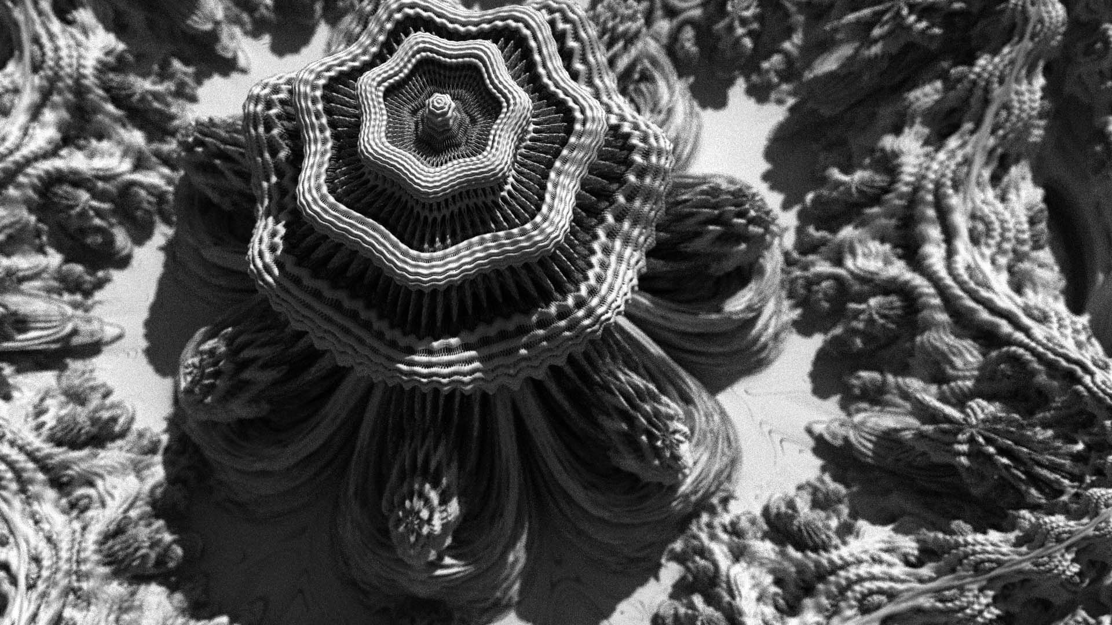
Figure 1: An example of how an image caption could look like.
Acknowledgements (optional)
Acknowledgments may be inserted at this section. Should the submitted work have been partially or entirely funded or supported by external sources, it is requisite to cite the financial contributors herein. Example: This work was partly funded by the European Union Example Program under grant number: 000-000-000.
Appendix (optional)
This section may be utilized for the inclusion of raw data or supplementary information deemed beneficial for the reader. Links to repositories (for code, gathered empirical data, etc.) may also be embedded within this segment, provided that these resources do not inadvertently disclose any authorial details. Should there be a requirement for an anonymized platform for the archival of research data, the utilization of OSF (Open Science Framework) is highly recommended. (https://osf.io/).
List of Figures
If your contribution uses more than ten figures you may include a list of figures here. You can also use this section to give proper credit if necessary. Additionally, this segment may serve to duly acknowledge and attribute proper (image) credit where warranted. It is important to note that the authors are responsible to ensure adherence to copyright laws, the payment of any applicable royalties, and the provision of image credits. You must ascertain that you possess the requisite permissions for the utilization and publication of each image incorporated within your work. Do not utilize external materials/media for which you cannot guarantee explicit authorization for publication under the Creative Commons license.
Conflict of Interest
Important: Give a brief statement of any potential conflicts of interest here. If the author(s) declare that there are no conflicts of interest regarding the publication of this paper. This assertion encompasses any potential conflicts that may arise from financial, personal, or professional relationships that could influence the research outcomes. Each author has thoroughly examined their affiliations, consultancies, stock ownership, honoraria, paid expert testimony, patent applications and registrations, and grants or other funding to confirm that there are no conflicts to disclose. This statement is intended to affirm our commitment to transparency and integrity in our research. If the authors identify any potential conflicts, please state them here.
References
Please use the APA bibliography style for your references (https://apastyle.apa.org/style-grammar-guidelines/references) Below you find some examples for the most common media types. If possible, try to include DOIs or other persistent identifiers (e.g. JSTOR-numbers etc.) in your references. When citing online resources make sure that you add the date of your last access to your reference.
Monography/book:
Augé, M. (1995), Non-Places. Introduction to an Anthropology of Supermodernity, London: Verso.
Journal article:
Gowdy, J. M. (2004). The Revolution in Welfare Economics and Its Implications for Environmental Valuation and Policy. Land Economics, 80(2), 239–257. https://doi.org/10.2307/3654741.
Online resources:
Bundesministerium für wirtschaftliche Zusammenarbeit und Entwicklung (2023) [cited as: BMZ], Stadtentwicklung, https://www.bmz.de/de/themen/stadtentwicklung/hintergrund-18138. Accessed: 28 February 2023.

Shakespeare 1801, pp. 6–1.
Doe 2020, p. 36.
Doe 1987, p. 652.
Sample 2006, pp. 15–16.
Doe 2023, p. 809.
Pattern 2016, p. 65; Smith 2008, pp. 177–178.

